**CHAPTER 4**

* **4.1- What are the differences among sequential access, direct access, and random access?** 
  + Sequential access is accessing data in a specific linear sequence, with an example being tape storage. Direct access has the data address being based on a physical location. With random access, any location can be selected at random, and the addressable locations in memory have a unique, physically wired-in addressing mechanism.
* **4.2-What is the general relationship among access time, memory cost, and capacity?** 
  + As access time becomes faster, the cost per bit increases. As memory size increases, the cost per bit is smaller. Also, with greater capacity, the access time becomes slower.
* **4.3- How does the principle of locality relate to the use of multiple memory levels?** 
  + Slower and less expensive memory is used in higher stages, with the most expensive being the registers in the processor as well as cache. Main memory is slower and less expensive, and is outside of the processor.
* **4.4- What are the differences among direct mapping and associative mapping,?** 
  + Direct mapping maps each block of main memory into only one possible cache line. Associative mapping permits each main memory block to be loaded into any line of the cache. The set-associative mapping combines both methods while decreasing disadvantages. The cache consists of a number of sets, each of which consists of a number of line.
* **4.5- For a direct-mapped cache, a main memory address is viewed as consisting of three fields. List and define the three fields.** 
  + The fields would be i, j, and m. I is the cache line number, j is the main memory block number, and m is the number of lines in the cache.
* **4.6- For an associative cache, a main memory address is viewed as consisting of two fields. List and define the two fields.** 
  + Tag and Word fields. Tag field uniquely identifies a block of main memory. The word is what is to be placed in the block of memory.

**CHAPTER 5**

**5.1 What are the key properties of semiconductor memory?**

• It has two (semi)stable states which can be used to represent binary 1 and 0  
• It supports read/write operations

**5.2 What are two interpretations of the term random-access memory?**

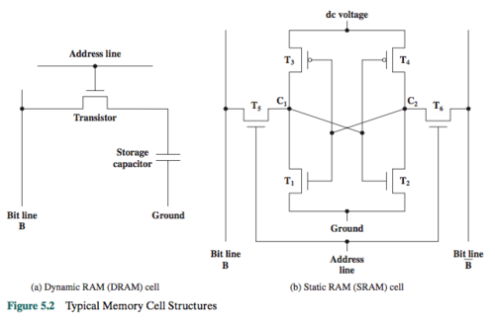• DRAM  
• SRAM

**5.3 What is the difference between DRAM and SRAM in terms of application?**

- SRAM is used for cache memory  
- DRAM is used for main memory

**5.4 What is the difference between DRAM and SRAM in terms of characteristics such as speed, size, and cost?**

- speed: SRAM is faster  
- size: SRAM takes more space, DRAM is denser  
- cost: SRAM is more expensive than DRAM

**5.5 Explain why one type of RAM is considered to be analog and the other digital.**

- DRAM: analog device because it stores charge and uses a threshold to determine the binary value  
- SRAM: digital because it uses flip-flop logic gates

**5.6 What are some applications for ROM?**

• Microprogramming  
• Library subroutines for frequently wanted functions  
• System programs  
• Function tables

**5.7 What are the differences among EPROM, EEPROM, and flash memory?**

EPROM:  
- read/written electrically  
- before writing, all cells must be erased by exposure to UV light  
- price: $  
  
EEPROM:  
- can be written to any time, without erasing contents  
- price: $$$  
  
flash memoy:  
- electrical erasing (in seconds), faster than EPROM  
- price: $$

**5.8 Explain the function of each pin in Figure 5.4b.**

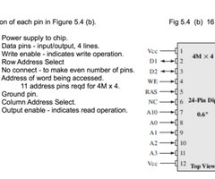

**5.9 What is a parity bit?**

* A bit appended to an array of binary digits to make the sum of all the binary digits, including the parity bit, always odd (odd parity), or always even (even parity).

**5.10 How is the syndrome for the Hamming code interpreted?**

* Each bit of the syndrome is 0 or 1 according to if there is or is not a match in that bit position for the two inputs.

**5.11 How does SDRAM differ from ordinary DRAM?**

* SDRAM:  
  - synchronous, unlike traditional DRAM  
  - synchronized with the system bus

CHAPTER 6

**6.1 What are the advantages of using a glass substrate for a magnetic disk?**

• increased disk reliability  
 • less surface defects  
 • better stiffness to reduce disk dynamics  
 • greater ability to withstand shock and damage

**6.2 How are data written onto a magnetic disk?**

* Pulses are sent to the write head, then an electric current magnetizes a small area of the recording medium to store the "pulses"

**6.3 How are data read from a magnetic disk?**

* The read head consists of a partially shielded magnetoresistive (MR) sensor that senses the magnetization of the medium
  1. **Explain the difference between a simple CAV system and a multiple zoned recording system.**

• Constant angular velocity (CAV) system: the number of bits per track is constant;  
 • An increase in density is achieved with multiple zoned recording, in which the surface is divided into a number of zones, with zones further from the centre containing more bits than zones closer to the centre.

**6.5 Define the terms track, cylinder, and sector.**

* Track - On a magnetic disk, data is organized on the platter in concentric sets of rings, called tracks.
* Cylinder - On a disk with multiple platters, the set of all tracks in the same relative position on the platter is referred to as a cylinder.
* Sector - Data are transferred to and from the disk in sectors.

**6.6 What is the typical disk sector size?**

* 512 bytes

**6.7 Define the terms seek time, rotational delay, access time, and transfer time.**

* Seek time - Time taken to position the head at the track.
* Rotational delay - Once the track is selected, the disk controller waits until the appropriate sector rotates to line up with the head. The time it takes for the beginning of the sector to reach the head is known as the rotational delay.
* Access time - The sum of the seek time, if any, plus the rotational delay. The time it takes to get into position to read or write.
* Transfer time - Time taken for data transfer. Once the head is in position, the read or write operation is performed as the sector moves under the head - data transfer portion of the operation.

**6.8 What common characteristics are shared by all RAID levels?**

* RAID is a set of physical disk drives viewed by the operating system as a single logical drive.
* Data are distributed across the physical drives of an array in a scheme known as striping.
* Redundant disk capacity is used to store parity information, which guarantees data recoverability in case of a disk failure.

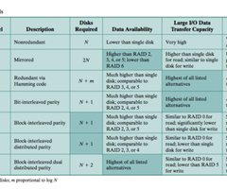**6.9 Briefly define the seven RAID levels**.

* RAID 0 - Non-redundant.
* RAID 1 - Mirrored, every disk has a mirror disk containing the same data.
* RAID 2 - Redundant via Hamming code; an error-correcting code is calculated across corresponding bits on each data disk, and the bits of the code are stored in the corresponding bit positions on multiple parity disks.
* RAID 3 - Bit-interleaved parity;
* RAID 4 - Block-interleaved parity;
* RAID 5 - Block-interleaved distributed parity;
* RAID 6 - Block-interleaved dual distributed parity;

**6.10 Explain the term striped data.**

* The disk is divided into strips, which may be physical blocks, sectors, or some other unit. The strips are mapped round robin to consecutive array members. A set of logically consecutive strips that maps exactly one strip to each array member is referred to as a stripe.

**6.11 How is redundancy achieved in a RAID system?**

* The disk is divided into strips, which may be physical blocks, sectors, or some other unit. The strips are mapped round robin to consecutive array members. A set of logically consecutive strips that maps exactly one strip to each array member is referred to as a stripe.

**6.12 In the context of RAID, what is the distinction between parallel access and independent access?**

* RAID 1: by having two identical copies of all data  
  The rest: by the use of error-correcting codes